5. a. Design a Java program that implements multi-level inheritance.
class Shape {
public void display() {
System.out.print("Inside Shape :");
}
}
class Rectangle extends Shape {
int L=10,W=20;
public void area() {
int A=L*W;
display(); // calling method of Shape
System.out.print(" Rectangle=>");
System.out.println(" Area="+A);
}
}
class Cube extends Rectangle {
public void volume() {
int H;
L=W=H=30;
int V=L*W*H;
display();// calling method of Shape
System.out.print(" Cube=>");
System.out.println(" Volume="+V);

}
}
public class multilevel {
public static void main(String[] args) {
Cube cubeObject = new Cube();
cubeObject.area();
cubeObject.volume();
}
}
OUTPUT:
C:\>javac multilevel.java
C:\>java multilevel
Inside Shape : Rectangle=> Area=200
Inside Shape : Cube=> Volume=27000
NOTE:
In multilevel inheritance, a subclass extends from a superclass and then the same subclass acts as a superclass for another class. Then each subclass can then become able to inherit the properties(data members and methods) of their respective superclasses. For example,
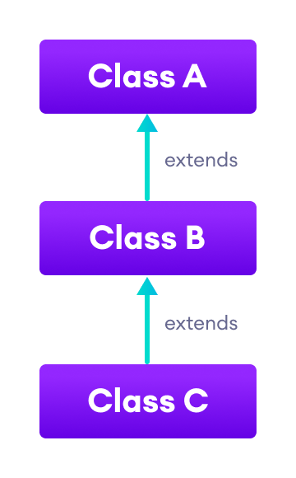
In our program , subclass Cube extends superclass Rectangle which in turn as subclass extends superclass Shape.

b. Design a Java program to illustrate Dynamic Method Dispatch using hierarchical inheritance.
class A
{
void show()
{
System.out.println("Inside A's show method");
}
}

class B extends A
{
// overriding show()
void show()
{
System.out.println("Inside B's show method");
}
}

class C extends A
{
// overriding show()
void show()
{
System.out.println("Inside C's show method");
}
}

// Driver class
class Dispatch
{
public static void main(String args[])
{
A a = new A();
B b = new B();
C c = new C();

// obtain a reference of type A
A ref;

ref = a; // ref refers to an A object
ref.show(); // calling A's version of show()

ref = b; // now ref refers to a B object
ref.show(); // calling B's version of show()

ref = c; // now ref refers to a C object
ref.show(); // calling C's version of show()
}
}

OUTPUT:

C:\>javac Dispatch.java
C:\>java Dispatch

Inside A's show method
Inside B's show method
Inside C's show method

NOTE:

Method overriding is one of the ways in which Java supports “Runtime Polymorphism” and this can be implemented in Java by “Dynamic method dispatch” technique. In this technique, a superclass reference variable refers to a subclass object. If a superclass contains a method that is overridden by a subclass, then when different types of objects are referred to through a superclass reference variable, different versions of the method are executed.

--------------------------------------------------------------------------------------------------------------------

